**MODUL**

**GENERAL ENGLISH I**



ARRANGED BY

**Andrysyah, S.Pd.I, M.Pd**

**POLITEKNIK LP3I MEDAN**

**MEDAN**

**2020**

### TABLE OF CONTENT

**COVER**

**DAFTAR ISI PAGE**

**UNIT 1**

1. Introduction 1
2. To be 2
3. Present Tense 2

**UNIT 2**

1. Daily Routines 5
2. WH – Questions 6

**UNIT 3**

1. My Leisure time 8
2. Modals 9

**UNIT 4**

1. Describing Place 12
2. Examples of Describing Place 13

**UNIT 5**

1. Getting Around 15
2. Prepositions 16

**UNIT 6**

1. How much is your red bag? 18
2. Past Tense 19

**UNIT 7**

1. I am studying English 23

**UNIT 8**

1. What does he look like? 26

**UNIT 9**

1. Fun weekend Activities 30

**UNIT 10**

1. Vacation 32

# **UNIT 1**

## **1. INTRODUCTIONS**

**a . How to introduce yourself ?**

If you have difficulty when it comes to introducing yourself to someone for the first time, you shouldn’t feel embarrassed. A lot of native speakers also become tongue-tied when talking about themselves!

You will be ready to answer the most common questions that people ask each other – particularly in professional situations and business contexts:

* *What is your name?*
* *Where are you from?*
* *What is your hobby?*
* *What do you do?*
* *What are your special skills?*
* *What are you passionate about?*

Below are some examples of phrases you can use to introduce yourself and give other people a clear understanding of who you are.

***Hello, my name is Matt Lemanski. I am the creator of Speaking of English, a blog for intermediate English learners who want to become more fluent in the language. I am originally from the United States and I currently live in Germany. I have been a teacher since 2008, and specialize in business writing and IELTS preparation. Before becoming a teacher, I worked as a copyeditor for government agencies in Washington DC and as a ghostwriter for startup founders and independent consultants around the world. In my free time, I enjoy hiking, practicing photography, and exploring the city by bicycle.***

**2. TO BE**

The verb ***to be*** is the fundamental verb used to indicate the existence of an entity (person, object, abstraction) or to relate an entity to its qualities or characteristics. In linguistics, it is sometimes known as a copula.

Unlike transitive verbs, it does not take a direct object, but a complement, since the subject and complement of the verb ***to be*** relate to the same entity.

| Person | | Present | Past tense | Present perfect |  | Past perfect |
| --- | --- | --- | --- | --- | --- | --- |
| **1st sing.** | **I** | **am** | **was** | **have been** |  | **had been** |
| **2nd sing** | **you** | **are** | **were** | **have been** |  |
| **3rd sing** | **he, she, etc.** | **is** | **was** | **has been** |  |
| **1st plural.** | **we** | **are** | **were** | **have been** |  |
| **2nd plural** | **you** | **are** | **were** | **have been** |  |
| **3rd plural** | **they** | **are** | **were** | **have been** |  |

**3. PRESENT TENSE**

The simple present tense is one of several forms of present tense in English. It is used to describe ***habits, unchanging situations, general truths, and fixed arrangements***. The simple present tense is simple to form. Just use the base form of the verb: (I take, you take, we take, they take) The 3rd person singular takes an -s at the end. (he takes, she takes). **The simple present is not used to express actions happening now.**

**The simple present tense is used:**

**Examples**

* **For habits**  
  He drinks tea at breakfast.  
  She only eats fish.  
  They watch television regularly.
* **For repeated actions or events**  
  We catch the bus every morning.  
  It rains every afternoon in the hot season.  
  They drive to Monaco every summer.
* **For general truths**  
  Water freezes at zero degrees.  
  The Earth revolves around the Sun.  
  Her mother is Peruvian.
* **For instructions or directions**  
  Open the packet and pour the contents into hot water.  
  You take the No.6 bus to Watney and then the No.10 to Bedford.
* **For fixed arrangements**  
  His mother arrives tomorrow.  
  Our holiday starts on the 26th March
* **With future constructions**  
  She'll see you before she leaves.  
  We'll give it to her when she arrives.

**Forming the simple present tense: to think**

| **Affirmative** |  | **Interrogative** | **Negative** |
| --- | --- | --- | --- |
| I think |  | Do I think? | I do not think |
| You think |  | Do you think? | You do not think |
| He thinks |  | Does he think? | He does not think |
| She thinks |  | Does she think? | She does not think |
| It thinks |  | Does it think? | It does not think |
| We think |  | Do we think? | We do not think. |
| They think |  | Do they think? | They do not think. |

**Notes on the simple present, third person singular**

* In the third person singular the verb **always ends in -s**:  
  *he want****s****, she need****s****, he give****s****, she think****s.***
* Negative and question forms use DOES (= the third person of the auxiliary 'DO') + the infinitive of the verb.  
  *He want****s*** *ice cream.* ***Does*** *he want strawberry? He* ***does*** *not want vanilla.*
* Verbs ending in **-y** : the third person changes the **-y** to **-ies**:  
  *fly --> fl****ies****, cry --> cr****ies***  
  **Exception**: if there is a vowel before the -**y**:  
  *play --> play****s****, pray --> pray****s***
* Add **-es** to verbs ending in:**-ss, -x, -sh, -ch**:  
  *he pass****es,*** *she catch****es,*** *he fix****es,*** *it push****es***

**Examples**

* **He goes** to school every morning.
* **She understands** English.
* **It mixes** the sand and the water.
* **He tries** very hard.
* **She enjoys** playing the piano.

**UNIT 2**

**1. DAILY ROUTINE**

a. What are some of the daily routine that you do at home?

**Examples :** I **wake up** at 7am every morning. I **press the snooze button** five times every morning before I **turn off the alarm** and **get up**. I **have a cup of coffee** and **make breakfast.** I usually **read the newspaper** while I **have breakfast**. My children like to **have a shower** after they have breakfast but I like to have a shower before I **get dressed.** My wife **brushes her long hair**, and I have short hair so I **comb my hair**. How do you **do your hair** in the morning? It is important to **brush your teeth**, and some women like to **put make-up on**. After I have finished work, I **go home** to **cook dinner.** In my house I usually **make dinner.** The family eat dinner together at 7:30pm. After dinner I make sure that my children **do their homework**, and then I **chill out on the sofa** and **watch television.**  On television I usually **watch the News.** My wife usually comes to tell me to **take the rubbish out,** or **wash the dishes.**  Our children **feed the dog and the cat** before they **go to bed** and I tell them to **go to the bathroom** too. If I am sick I have to **take my medication,** but then I **get into my pyjamas** and **set the alarm** so I wake up in the morning. The last things I do is **lock the door**, **turn off the lights**, and **go to bed**. It doesn't take me long to **fall asleep**.

b. Exercise

a. Please Record your daily routines and upload to youtube ! the duration at least 10 minutes !

b. Upload your interesting 3 daily routines to your IG !

**2. WH-QUESTIOS**

WH-questions are questions starting with WH-words including: *what, when, where, who, whom, which, whose, why and how.* Question words are used to ask about specific qualities, times, places, people and so on. Below is a list of question words and example sentences:

|  |  |  |  | | **Question words** | **Meaning** | **Examples** | | --- | --- | --- | | **who** | person | Who's that? That's Nancy. | | **where** | place | Where do you live? In Boston | | **why** | reason | Why do you sleep early? Because I've got to get up early | | **when** | time | When do you go to work? At 7:00 | | **how** | manner | How do you go? By car | | **what** | object, idea or action | What do you do? I am an engineer | | **which** | choice | Which one do you prefer? The red one. | | **whose** | possession | Whose is this book? It's Alan's. | | **whom** | object of the verb | Whom did you meet? I met the manager. | | **what kind** | description | What kind of music do you like? I like quiet songs | | **what time** | time | What time did you come home? | | **how many** | quantity (countable) | How many students are there? There are twenty. | | **how much** | amount, price (uncountable) | How much time have we got? Ten minutes | | **how long** | duration, length | How long did you stay in that hotel? For two weeks. | | **how often** | frequency | How often do you go to the gym? Twice a week. | | **how far** | distance | How far is your school? It's one mile far. | | **how old** | age | How old are you? I'm 16. | | **how come** | reason | How come I didn't see you at the party? | |  |
| --- | --- | --- | --- | --- | --- | --- | --- | --- | --- | --- | --- | --- | --- | --- | --- | --- | --- | --- | --- | --- | --- | --- | --- | --- | --- | --- | --- | --- | --- | --- | --- | --- | --- | --- | --- | --- | --- | --- | --- | --- | --- | --- | --- | --- | --- | --- | --- | --- | --- | --- | --- | --- | --- | --- | --- | --- | --- | --- | --- | --- | --- | --- |
|  |  |  |  |  |  |
|  |  |  |  |  |  |
|  |  |  |  |  |  |
|  |  |  |  |  |  |
|  |  |  |  |  |  |
|  |  |  |  |  |  |
|  |  |  |  |  |  |
|  |  |  |  |  |  |
|  |  |  |  |  |  |
|  |  |  |  |  |  |
|  |  |  |  |  |  |
|  |  |  |  |  |  |
|  |  |  |  |  |  |
|  |  |  |  |  |  |
|  |  |  |  |  |  |
|  |  |  |  |  |  |
|  |  |  |  |  |  |
|  |  |  |  |  |  |

**UNIT 3**

**1. MY LEISURE TIME**

a. What is your leisure time activities?

Leisure is the time when a man is free from routine work and can do whatever he like best. In a word, it is a temporary relief from the monotonous routine task of our daily life. People like to spend their leisure in their own way. Village people spend their leisure by flying kites, fishing, playing, swimming and gardening. City people spend their leisure by shopping, reading books, watching television, using computer, going park and zoo. In the high competition of education, we get little leisure time. Whenever I get time, I read books. I enjoy reading very much. Detective stories and biography of great persons are my favourite topics. I also like visiting unseen and unknown places. But it is not possible without parents’ company. My another favourite leisure activity is watching TV. Discovery and National Geography are my favourite channels. I also like cartoons. We have a garden behind our house. I want to work there in my free time but my parents don’t allow me to work there. However, I spend my leisure time with great merriment.

b. Please write down your leisure time in three paragraph !

**2. MODALS**

**a. What are modal verbs?**

Modals (also called modal verbs, modal auxiliary verb**s,** modal auxiliaries) are special verbs which behave irregularly in English. They are different from normal verbs like "work, play, visit..." They give additional information about the *function*of the main verb that follows it. They have a great variety of *communicative functions***.**

**b. Here are some characteristics of modal verbs :**

They never change their form. You can't add "s", "ed", "ing"...

They are always followed by an infinitive without "to" (e.i. the bare infinitive.)

They are used to indicate modality allow speakers to express certainty, possibility, willingness, obligation, necessity, ability

### c. List of modal verbs

Here is a list of modal verbs:

| ***can, could, may, might, will, would, shall, should, must*** |
| --- |

The verbs or expressions ***dare*, *ought to*, *had better*,** and ***need not*** behave like modal auxiliaries to a large extent and my be added to the above list

**d. Use of modal verbs:**

Modal verbs are used to express functions such as:

1. Permission
2. Ability
3. Obligation
4. Prohibition
5. Lack of necessity
6. Advice
7. Possibility
8. probability

### e. Examples of modal verbs

Here is a list of modals with examples:

| **Modal Verb** | **Expressing** | **Example** |
| --- | --- | --- |
| **must** | Strong obligation | You must stop when the traffic lights turn red. |
| logical conclusion / Certainty | He must be very tired. He's been working all day long. |
| **must not** | prohibition | You must not smoke in the hospital. |
| **can** | ability | I can swim. |
| permission | Can I use your phone please? |
| possibility | Smoking can cause cancer. |
| **could** | ability in the past | When I was younger I could run fast. |
| polite permission | Excuse me, could I just say something? |
| possibility | It could rain tomorrow! |
| **may** | permission | May I use your phone please? |
| possibility, probability | It may rain tomorrow! |
| **might** | polite permission | Might I suggest an idea? |
| possibility, probability | I might go on holiday to Australia next year. |
| **need not** | lack of necessity/absence of obligation | I need not buy tomatoes. There are plenty of tomatoes in the fridge. |
| **should/ought to** | 50 % obligation | I should / ought to see a doctor. I have a terrible headache. |
| advice | You should / ought to revise your lessons |
| logical conclusion | He should / ought to be very tired. He's been working all day long. |
| **had better** | advice | You 'd better revise your lessons |

Remember : **Modal verbs are followed by an infinitive without "to", also called the bare infinitive.**

Examples: You **must stop** when the traffic lights turn red.

You **should see** to the doctor.

There are a lot of tomatoes in the fridge. You **need not buy** any.

**UNIT 4**

**1. DESCRIBING PLACE**

**a. How to Describing Places?**  
to describing place need three steps or we know by generic structure. The first Introduction, the second Main Body, and the third conclusion. And the explanation below :

1. **Introduction**

It’s opening of the text and giving the information about the name and location. For introduction, you give the reasons why you chose that place, for example, what makes a place famous, what makes it special, etc.

1. **Main Body**

The main body is the essence point of this story. the usually starts from telling from the general part, then tells the specific part so that it becomes a conical story. For example, when we tell about a place, we can start from the overall characteristics of a place such as how the landscape, buildings, weather, and etc. then refer to specific details that complement the previous general explanation.

1. **Conclusion**   
   the conclusion of the author after visiting the place. that describes your feelings, or opinions of the place, you can also provide recommendations for readers who will visit the place.

**The vocabularies**

| **Vocab** | **Meanings** | **Vocab** | **Meanings** |
| --- | --- | --- | --- |
| Ancient | Kuno/langka | Beautiful | indah |
| Boring | Membosankan | crowded | Penuh sesak |
| Charming | Indah | Exciting | Menyenangkan |
| Expensive | Mahal | Famous | Terkenal |
| Fantastic | Fantastis | Fascinating | Menarik |
| Huge | Besar/luas | Historic | Bersejarah |
| Popular | Terkenal | Polluted | Tercemar |
| Peaceful | Damai | Stunning | Menakjubkan |
| Noisy | Berisik | Rural | Pedesaan |
| Mountainous | Pegunungan | Fertile | Subur |
| Dry | Kering | Alive | Hidup |
| Amazing | Luar biasa | Calm | Tenang |
| Creepy | Menyeramkan | Deserted | Area Gurun |
| Different | Berbeda | Fresh | Segar |
| Incredible | Luar biasa | Interesting | Menarik |
| Magnificent | Luar biasa | Modern | Modern |
| Natural | Alami | Perfect | Sempurna |
| Pleasant | Menyenangkan | Unusual | Tidak biasa |
| Unique | Unik | Warm | Hangat |
| Wild | Liar | Tropical | Tropis |
| Mysterious | Misterius | Romantic | Romantis |

**2. Examples of Describing Places**

**Jeju-do, Korea, the Island of the Gods**

          Jeju Island or also known as Jeju-do (a short form of Jeju Special Autonomous Province) is the only special autonomous province of South Korea and the country’s largest island. It’s situated southwest of Jeollanam-do Province in the Korea Strait, a sea passage between South Korea and Japan. Although the island isn’t a famous destination for the western people, the Asians are very familiar with its amazing geographic and cultural potential. In the last few years, its popularity has grown, especially for the young couples which seem to consider the island a mystic  and romantic place. In time, it became one of the most visited places in East Asia, with more than four million visitors from mainland Korea, Japan, and China every year.

          Jeju Island is a volcanic island created entirely from volcanic eruptions approximately 2 million years ago and is dominated by Halla-san (Halla Mountain): a volcano 1,950 meters high and the highest mountain in South Korea.

          Because of the relative isolation, the people of Jeju have developed a culture and language that are different from those of mainland Korea, with many local legends and mystic beliefs. They even named it the “Island of the Gods”, taking after a legend that tells the story of demi-gods that lived on the island, considered to be the progenitors of Jeju people. Distinct cultural artifacts and stones with different shapes that are considered protective for the locals can be found here.

          With a huge variety of landscapes, from long beaches to mountains and waterfalls, Jeju Island could turn out to be a thrilling experience. Cheonjeyeon and Cheonjiyeon waterfalls, Mount Halla, Hyeobje cave and Hyeongje island are just some of the popular sights on the island.

          Depending on the season, Jeju hosts unsual festivals such as a penguin swimming contest in winter, a cherry blossom festival in spring, the midsummer night beach festival in summer and Jeju horse festival in autumn. Aside from these events, many activities can be done in Jeju such as horse riding, hunting, fishing, mountain climbing, hiking.

**My House**

          My House is divided into two floors. On downstairs, I have all the important parts of the house such as the kitchen, bathrooms, storage room and parking garage. On upstairs I have one room where I keep the washer and dryer and one big terrace. Downstairs, the floor is divided in eight rooms, four of them are bedrooms, other two are bathrooms and then one kitchen and one dining room. In my bedroom, I have a lot of things inside, such as a television, a playstation 3, and many tropies.  In my sister's bedroom, there is a computer and in the other two bedrooms are for my parent and my other sister. Normally we eat in everywhere we want, but on Sunday we eat together in the dining room. I really love my house, the place where we could share everything together

**UNIT 5**

* 1. **GETTING AROUND**

**a. ASKING DIRECTIONS**

* Can/would/could you tell me where ..... is
* Can/would/could you show me where ... is ?
* Can/would/could you tell/show me where... located ?
* (dimana lokasi?  
  Can/would/could you tell/show me the way to
* Where is .... ?
* Where ....is ?
* How do I get to .... ?

**b. GIVING DIRECTIONS**

* Go straight on
* Keep walking around/about + time/distance
* Turn right
* turn left
* It is at the corner of the street
* It is accross ....
* It is in front ...
* It is behind ...
* It is next to .... / It is beside …
* after that, next, then
* Go ahead
* Follow me, I’ll show you the way
* This way
* That way
* Over there
* Over here
* Take this/that way
* You will find a junction
* You will find a crossroad

**c. Examples**

a. Excuse me,.. how do I get to suzuya in marelan ? I am from lp3i Marelan

b. ok , from your right turn right, go straight on from platina raya street, and you will meet crossroad then turn left, go straight on from tanah 600 street and the suzuya in your left, across the gas stations

* 1. **PREPOSITIONS**

**a**. A **preposition** is a word that indicates the relationship between a [noun](https://www.learngrammar.net/english-grammar/noun) and the other words of a sentence. They explain relationships of sequence, space, and logic between the object of the sentence and the rest of the sentence. They help us understand order, time connections, and positions.

**Example:**

* I am going to Canada.
* Alex threw a stone into the pond.
* The present is inside the box.
* They have gone out of the town.

***b. Types of Preposition***

Most of the prepositions have many uses. There are some prepositions which are common in every type of preposition as they function in a versatile way.

1. **Prepositions of Time:**

**Prepositions of time** show the relationship of time between the nouns to the other parts of a sentence. ***On, at, in, from, to, for, since, ago, before, till/until, by***, etc. are the most common preposition of time.

**Example:**

He started working at 10 AM.

The company called meeting on 25 October.

There is a holiday in December.

He has been ill since Monday.

Prepositions of Place and Direction:

1. **Prepositions of place** show the relationship of place between the nouns to the other parts of a sentence. ***On, at, in, by, from, to, towards, up, down, across, between, among, through, in front of, behind, above, over, under, below,*** etc. are the most common prepositions of place/direction.

**Example:**

He is at home.

He came from England.

The police broke into the house.

I live across the river.

Prepositions of Agents or Things:

**Prepositions of agents or things** indicate a casual relationship between nouns and other parts of the sentence.

***Of, for, by, with, about***, etc. are the most used and common prepositions of agents or things.

**Example:**

This article is about smartphones.

Most of the guests have already left.

I will always be here for you.

He is playing with his brothers.

Phrasal Prepositions:

1. **A** **phrasal preposition** is not a prepositional phrase, but they are a combination of two or more words which functions as a preposition. ***Along with, apart from, because of, by means of, according to, in front of, contrary to, in spite of, on account of, in reference to, in addition to, in regard to, instead of, on top of, out of, with regard to***, etc. are the most common phrasal prepositions.

**Example:**

They along with their children went to Atlanta.

According to the new rules, you are not right.

In spite of being a good player, he was not selected.

I’m going out of the city.

**UNIT 6**

1. **HOW MUCH IS THE RED BAG?**

When we want to know the quantity or amount of something, we ask questions starting with ***How much*** and ***How many***.

### HOW MUCH ...? (Quantity)

**How much** is used with uncountable nouns.

HOW MUCH + UNCOUNTABLE NOUN

* **How much** time do we have to finish the test?
* **How much** money did you spend?
* **How much** sugar would you like in your coffee?
* **How much** paper will I need?
* **How much** milk is in the fridge?
* **How much** traffic was there on the way to work?

If the verb **To Be** is used with an uncountable noun, it is in singular form (= IS or WAS etc.)

### HOW MUCH ...? (Price)

**How much** can also be used when we want to know the PRICE of something.

In this case, we can use **How much** with countable nouns (both singular and plural nouns).

* **How much** is that painting?
* **How much** are those shoes?
* **How much** did your jacket cost?
* **How much** is the dress on display in the window?
* **How much** will it cost me?
* **How much** does it cost ?

### HOW MANY ...? (Quantity)

**How many** is used when we want to know the QUANTITY of something.

It is only used with plural countable nouns.

HOW MANY + PLURAL NOUN

* **How many** days are there in January?
* **How many** people work in your company?
* **How many** cousins do you have?
* **How many** books did you buy?
* **How many** countries are there in the world?
* **How many** students are in the class right now?
* **How many** chairs are there in this room?
* **How many** pieces of chocolate would you like?

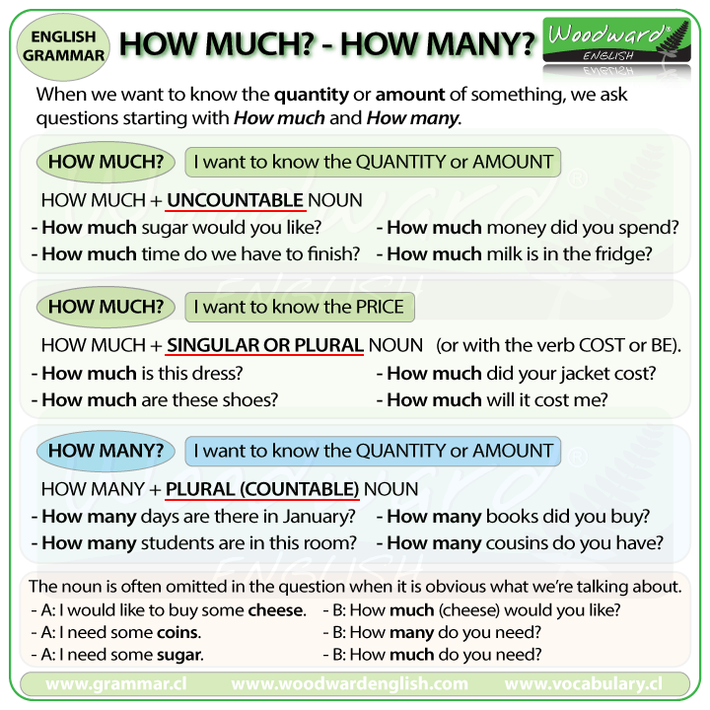

**2. PAST TENSE**

a. The **Past Simple** [tense](https://www.usingenglish.com/glossary/tense.html), also called the **Simple Past**, is used for past actions that happened either at a specific time, which can either be given by a time phrase (*yesterday*, *last year*, etc.) or understood from the context. [Regular Verbs](https://www.usingenglish.com/glossary/regular-verb.html) add **-ed** to the [base form](https://www.usingenglish.com/glossary/base-form.html), or **-d** if the verbs ends with **-e**. [Irregular verbs](https://www.usingenglish.com/glossary/irregular-verb.html) can change in many different ways. The verb form is the same for all [persons](https://www.usingenglish.com/glossary/person.html) :

## **b. Simple Past Forms**

The simple past is formed using the **verb + ed**. In addition, there are many [verbs with irregular past forms](https://www.englishpage.com/irregularverbs/irregularverbs.html). Questions are made with *did* and negative forms are made with *did not*.

* Statement: You **called** Debbie.
* Question: **Did** you **call** Debbie?
* Negative: You **did not call** Debbie.

## **Simple Past Uses**

### USE 1 Completed Action in the Past

simple past completed action

Use the simple past to express the idea that an action started and finished at a specific time in the past. Sometimes, the speaker may not actually mention the specific time, but they do have one specific time in mind.

Examples:

* I **saw** a movie yesterday.
* I **didn't see** a play yesterday.
* Last year, I **traveled** to Japan.
* Last year, I **didn't travel** to Korea.
* **Did** you **have** dinner last night?
* She **washed** her car.
* He **didn't wash** his car.

### USE 2 A Series of Completed Actions

simple past series

We use the simple past to list a series of completed actions in the past. These actions happen 1st, 2nd, 3rd, 4th, and so on.

Examples:

* I **finished** work, **walked** to the beach, and **found** a nice place to swim.
* He **arrived** from the airport at 8:00, **checked** into the hotel at 9:00, and **met** the others at 10:00.
* **Did** you **add** flour, **pour** in the milk, and then **add** the eggs?

### USE 3 Duration in the Past

simple past duration

The simple past can be used with a duration which starts and stops in the past. A duration is a longer action often indicated by expressions such as: for two years, for five minutes, all day, all year, etc.

Examples:

* I **lived** in Brazil for two years.
* Shauna **studied** Japanese for five years.
* They **sat** at the beach all day.
* They **did not stay** at the party the entire time.
* We **talked** on the phone for thirty minutes.
* A: How long **did** you **wait** for them?
* B: We **waited** for one hour.

### USE 4 Habits in the Past

simple past habit

The simple past can also be used to describe a habit which stopped in the past. It can have the same meaning as "[used to](https://www.englishpage.com/verbpage/usedto.html)." To make it clear that we are talking about a habit, we often add expressions such as: always, often, usually, never, when I was a child, when I was younger, etc.

Examples:

* I **studied** French when I was a child.
* He **played** the violin.
* He **didn't play** the piano.
* **Did** you **play** a musical instrument when you were a kid?
* She **worked** at the movie theater after school.
* They never **went** to school, they always **skipped** class.

**UNIT 7**

**1. I AM STUDYING ENGLISH**

**a. PRESENT continuous** (also called present progressive) is a [verb tense](https://www.englishpage.com/verbpage/verbtenseintro.html) which is used to show that an ongoing action is happening now, either at the moment of speech or now in a larger sense. The present continuous can also be used to show that an action is going to take place in the near future. Read on for detailed descriptions, examples, and present continuous exercises.

## **b. Present Continuous Forms**

The present continuous is formed using ***am/is/are* + present participle**. Questions are indicated by inverting the subject and *am/is/are*. Negatives are made with *not*.

* Statement: You **are watching** TV.
* Question: **Are** you **watching** TV?
* Negative: You **are not watching** TV.

## **c. Present Continuous Uses**

### USE 1 Now

present continuous now

Use the present continuous with [normal verbs](https://www.englishpage.com/verbpage/types.html) to express the idea that something is happening now, at this very moment. It can also be used to show that something is not happening now.

Examples:

* You **are learning** English now.
* You **are not swimming** now.
* **Are** you **sleeping**?
* I **am sitting**.
* I **am not standing**.
* **Is** he **sitting** or **standing**?
* They **are reading** their books.
* They **are not watching** television.
* What **are** you **doing**?
* Why **aren't** you **doing** your homework?

### USE 2 Longer Actions in Progress Now

present continuous longer duration

In English, "now" can mean: this second, today, this month, this year, this century, and so on. Sometimes, we use the present continuous to say that we are in the process of doing a longer action which is in progress; however, we might not be doing it at this exact second.

Examples: (All of these sentences can be said while eating dinner in a restaurant.)

* I **am studying** to become a doctor.
* I **am not studying** to become a dentist.
* I **am reading** the book *Tom Sawyer.*
* I **am not reading** any books right now.
* **Are** you **working** on any special projects at work?
* **Aren't** you **teaching** at the university now?

### USE 3 Near Future

present continuous near future

Sometimes, speakers use the present continuous to indicate that something will or will not happen in the near future.

Examples:

* I **am meeting** some friends after work.
* I **am not going** to the party tonight.
* **Is** he **visiting** his parents next weekend?
* **Isn't** he **coming** with us tonight?

### USE 4 Repetition and Irritation with "Always"

present continuous always habit

The present continuous with words such as "always" or "constantly" expresses the idea that something irritating or shocking often happens. Notice that the meaning is like [simple present](https://www.englishpage.com/verbpage/simplepresent.html), but with negative emotion. Remember to put the words "always" or "constantly" between "be" and "verb+ing."

Examples:

* She **is always coming** to class late.
* He **is constantly talking**. I wish he would shut up.
* I don't like them because they **are always complaining**.

**UNIT 8**

* 1. **WHAT DOES HE LOOK LIKE ?**

## **a. How to Describe People ?**

An adjective is a describing word, the main syntactic role of which is to qualify a noun or noun phrase, giving more information about the object signified.

In this lesson, we will learn useful [Adjectives](https://www.eslbuzz.com/common-adjectives-in-english/) to describe people in three ways:

*1. Describing someone’s appearance*

*2. Describing someone’s character and personality*

*3. Describing someone’s feelings & emotions*

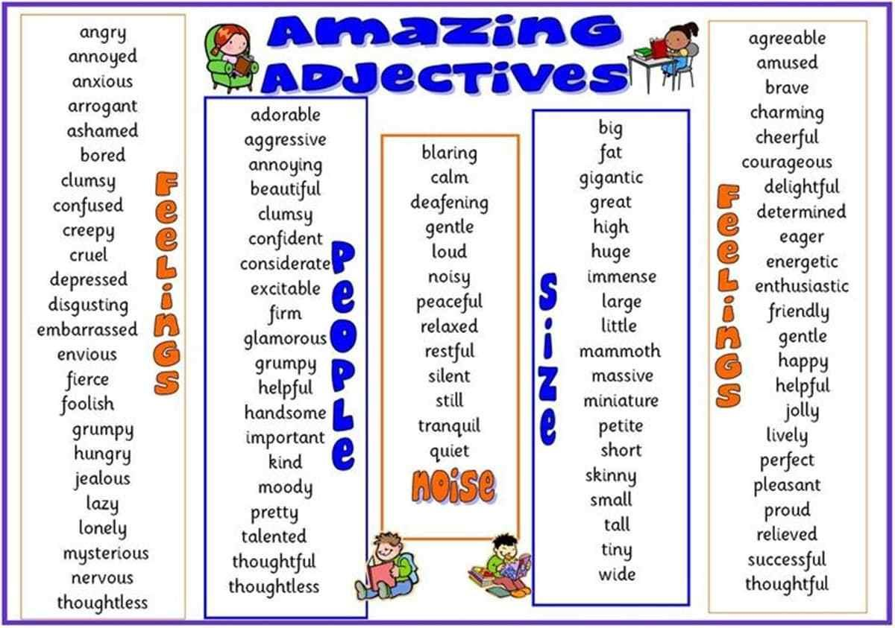

**1. Describing Someone’s Appearance**

Appearance is defined as the way someone or something looks.

This is list of adjectives to describe a person’s appearance:

beautiful*(My younger sister is very beautiful.)*

handsome *(He’s the most handsome man I’ve ever met.)*

cute *(That’s a cute little baby.)*

thin *(She was looking pale and thin.)*

tall *(She’s tall and thin.)*

chubby *(She was eleven years old and pretty in a chubby sort of way.)*

muscular *(He was tall, lean and muscular.)*

attractive *(The actress is an attractive woman.)*

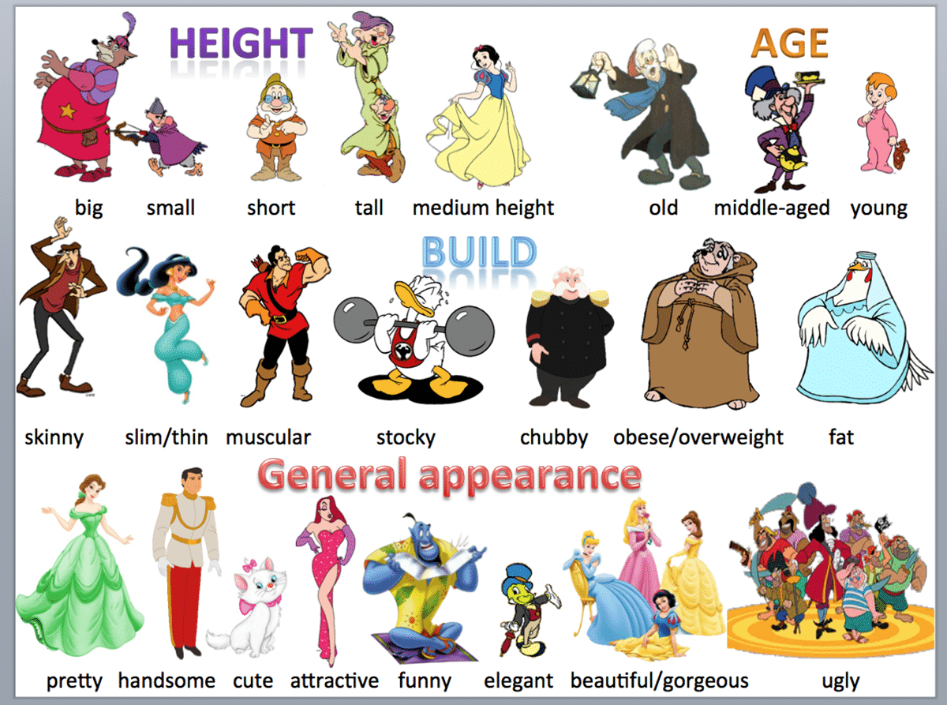

**2. Describing Someone’s Character and Personality**

Character traits are qualities or characteristics that describe what a person is like. It’s important to be able to describe your own personality or someone else’s.

Here is a list of English Adjectives to describe someone’s personality.

polite *(Please be polite to our guests.)*

friendly *(Everyone was very friendly towards me.)*

honest *(He was a hard-working honest man.)*

generous *(She’s always very generous to the kids.)*

rude *(She was very rude about my driving.)*

lazy *(He is the laziest boy in the class.)*

angry *(I was very angry with myself for making such a stupid mistake.*

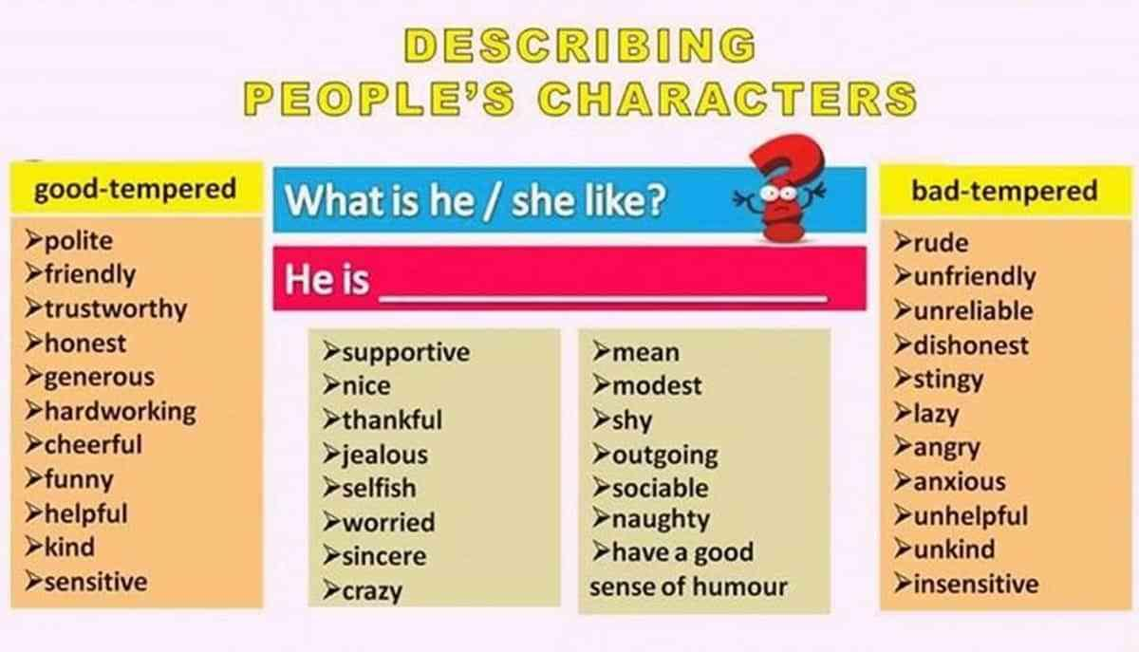

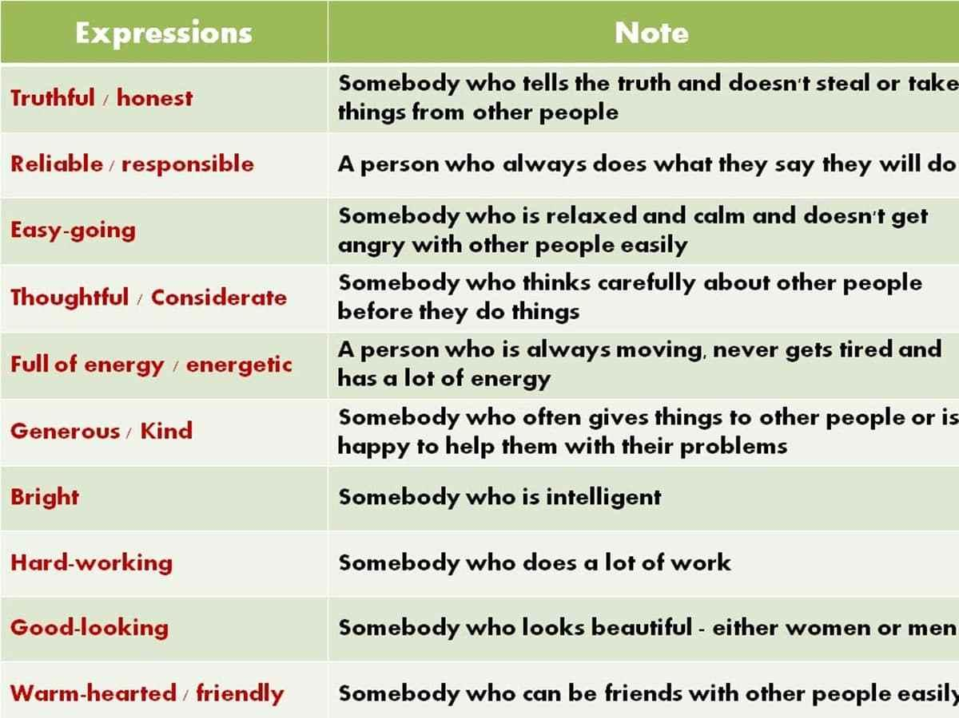

**3. Describing Someone’s Feelings & Emotions**

Sometimes it’s hard to explain exactly how you feel. This vocabulary list helps you narrow down exactly what word best expresses your current emotional state.

terrified *(She looked at him with wide, terrified eyes.)*

exhausted *(You look absolutely exhausted.)*

scared *(People are scared to use the buses late at night.)*

nervous *(She was so nervous about her exams that she couldn’t sleep.)*

embarrassed *(She’s embarrassed about her height.)*  
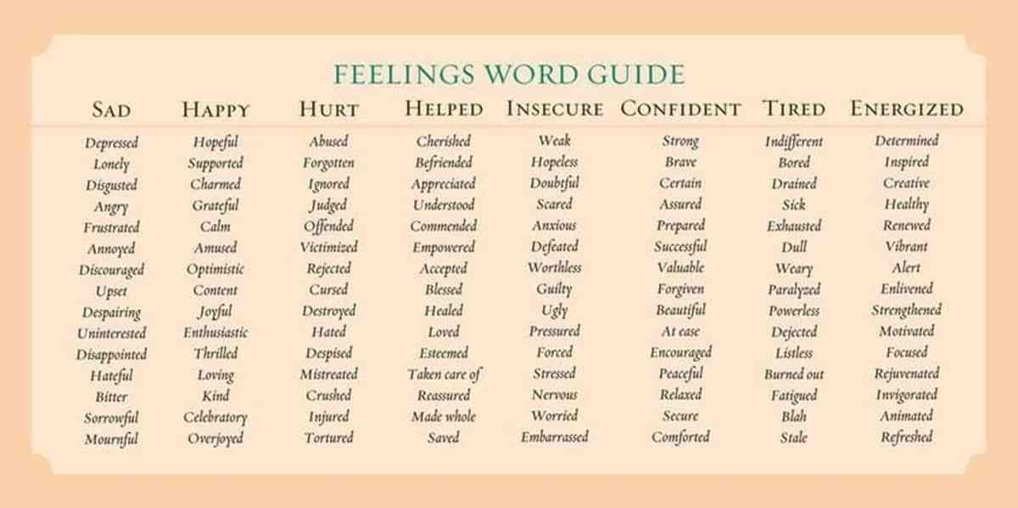

**UNIT 9**

* 1. **FUN WEEKEND ACTIVITIES**

# **Would You Like..?**

## **Would you like + noun**

How to use "would like" with a noun?

"Would like" has the meaning of  "want",  but it is used for more polite expressions. Do you want  some coffee?  ( This is less formal and polite. We usually use this for friends, children, and etc.)

Would you like some coffee? (This is more polite and formal.)

***1. We can use it with a noun:***Form:  Subject + would like + noun

I would like a glass of cola.

Would you like some water?

She would like a piece of cake.

***2. We can use it in positive, negative sentences and questions.***

I would like some coffee.

She would like a new pair of shoes.

Would you like some water?

Would you like an apple?

He wouldn't like a sandwich.

Mary wouldn't like  an ice -cream.

***3. "Would like" is the same for all subjects.***

I would like some soup.

You would like some soup.

He / she / James would like some soup.

We would like some soup.

They / our friends would like some soup.

**Contractions:**  
We can make them shorter by using contractions:

 I would like = I'd like  
She would like = She'd like /he'd    
They would like = They'd like  
We would like = We'd like  
You would like = You'd like **Example Sentences:**

I'd like some milk.

I'd  like some olives.

I'd  like some eggs.

I'd  like some bread.

**UNIT 10**

* 1. **VACATION**

1. **How to tell story in past events?**

A very useful skill in English is to be able to tell a story or an anecdote. Anecdotes are short stories about something that happened to you or someone you know.  So in this lesson you will learn to convey past events in words. First step to tell a story is to link your ideas together. Once you sequence them it is easy for you to put it in words.

**1. Beginning**

If you are going to tell your story after someone else has already spoken to you, then you can start by saying:

*That reminds me!*

*Something similar happened to me.*

*Words like Firstly, to start off with can help you to start telling your story or any past event.*

**2. Continuing**

Words that help you to connect or continue your story are:

*Then*

*After that*

*Next*

**3. Interruptions / New elements to the story**

While you are telling your story and certain elements have to be added then you can use words like:

*Suddenly*

*Unexpectedly*

1. **Ending**

To end the story words that can be used are:

*Finally*

*In the end*

*Eventually*

*Lastly*

1. **Tenses**

Varieties of tenses are used to tell stories such as:

**1) Present Tense** – used for telling jokes, or to give a dramatic effect.

**2) Past simple**– used to tell a story in a chronological order

**3) Past continuous** – used to describe activities in progress at the time of your story or give a background to it.

Use wide range of vocabulary to make your story interesting and hope you enjoy this lesson.